CHAPTER 3

REQUIREMENTS & ANALYSIS
The success of any software project relies heavily on a well-structured and thorough understanding of its requirements and functional goals. This chapter focuses on the detailed analysis of the Digital Fundraising Portal System by identifying the problem it aims to solve, the needs of its end-users, and the specific requirements—both functional and non-functional—that must be fulfilled to ensure the system's effectiveness.

3.1 PROBLEM DEFINITON
In recent years, digital fundraising has become a vital tool for individuals and organizations to gather financial support for creative, entrepreneurial, or social initiatives. However, traditional methods of online fundraising often suffer from significant limitations that affect both project creators and supporters. Project creators typically face challenges in reaching a broader audience beyond their immediate networks. They also encounter difficulty in establishing credibility and trust, as potential supporters often lack adequate information or verification regarding the legitimacy of the campaigns.

Moreover, conventional fundraising platforms lack transparency in tracking financial contributions and campaign progress. Supporters frequently feel disconnected due to limited updates or engagement opportunities. Many platforms also fail to offer structured reward mechanisms that motivate backers to contribute at varying levels. These inefficiencies can reduce the effectiveness of fundraising efforts and discourage continued participation.

Security remains a critical concern. Without robust systems to handle transactions, users are vulnerable to fraud, data breaches, and payment errors. The absence of a secure infrastructure deters users from sharing financial and personal information, thereby undermining the trustworthiness of the platform.

The Digital Fundraising Portal System is proposed as a comprehensive solution to these issues. This web-based platform provides a secure, user-friendly environment for launching and managing fundraising campaigns. It facilitates transparent engagement between campaign creators and supporters by integrating real-time progress tracking, secure payment handling, social media sharing capabilities, and tiered contribution options. An integrated admin dashboard ensures campaign authenticity and user safety through active monitoring and control.

3.2 REQUIREMENTS SPECIFICATION
The Requirement Specification defines the essential functionalities, features, and constraints of the Digital Fundraising Portal System. It serves as the foundation for system design, development, and validation. The requirements are categorized into Functional Requirements and Non-Functional Requirements.

3.2.1 FUNCTIONAL REQUIREMENTS
- User registration and role-based authentication
- Campaign creation with tier-based rewards.
- Real-time tracking of fundraising progress.
- Social media sharing to promote projects.
- Admin dashboard for project moderation and user management.
- Secure payment integration and contribution management.

3.2.2 NON-FUNCTIONAL REQUIREMENTS
- System should be responsive and mobile-friendly.
- Ensure data privacy and user security.
- High availability and scalability for multiple users.
- User-friendly interface for easy navigation.
- Compliance with legal and financial regulations.

3.3 PLANNING AND SCHEDULING
The development of the Digital Fundraising Portal System was carried out in a phased approach to ensure organized and timely progress. The project began with the requirement analysis phase, where the core features and system objectives were identified. This was followed by the design phase, where wireframes, database schema, and user flow diagrams were created.
Once the design was finalized, development was divided into frontend and backend modules. The frontend team focused on building the user interface using React and styling libraries, while the backend work involved setting up Supabase for authentication, real-time data handling, and database management.
The system was implemented module by module—starting with user registration, then project creation, followed by campaign tracking and payment integration. Regular testing was conducted at each stage to ensure stability and data integrity. Weekly milestones were tracked to monitor progress, and adjustments were made as necessary to align with the project timeline. The final phase involved integration, system testing, deployment, and user feedback collection.
Table 3.1: Project Plan
Phase | Start Date | End Date | Duration
Inception Phase | 20/06/2025 | 03/07/2025 | 14
Elaboration Phase | 10/07/2025 | 27/07/2025 | 18
Construction Phase | 26/08/2025 | 20/09/2025 | 26
Transition Phase | 24/09/2025 | 25/10/2025 | 32

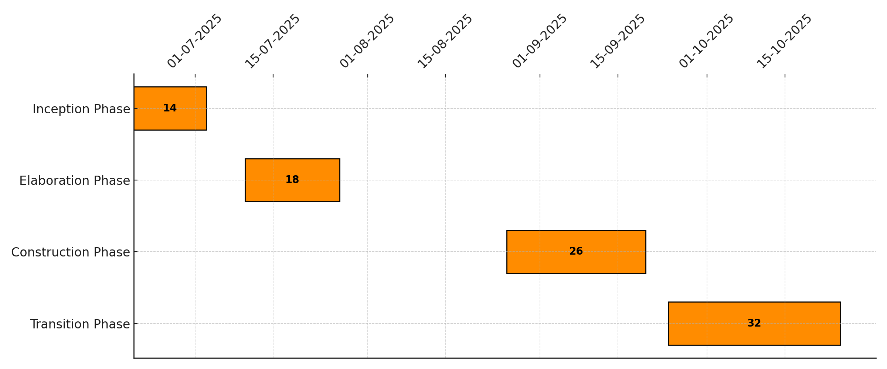
Figure 3.1: Gantt Chart for Project Plan
Table 3.2: Project Plan Phases
Phase | Description | Milestone
Inception Phase | Define the project vision, scope, feasibility, and success criteria. Conduct high-level risk analysis to ensure project viability. | Approved project charter  Feasibility report  Initial technology and tool selection
Elaboration Phase | Design system architecture, finalize user roles and requirements, and define key modules. Identify technical challenges and build initial prototypes. | UI/UX wireframes  Database schema design  Core module prototypes  Updated risk analysis
Construction Phase | Develop full application modules, including frontend and backend integration. project creation | Fully functional beta system  Test reports  Real-time data tracking and role-based access
Transition Phase | Deploy the platform, perform validation and user testing. Prepare training documentation and handover system for ongoing maintenance and monitoring. | Final deployment  Admin and user manuals  Production-ready system  Project sign-off

Table 3.3: Project Schedule
Task Name | Start Date | End Date | Duration
Architectural Prototype (Design) | 14/07/2025 | 05/08/2025 | 23
Construction | 07/09/2025 | 25/09/2025 | 19
Transition (Implementation and Training) | 04/10/2025 | 28/10/2025 | 25

Figure 3.2: Gantt Chart for Project Schedule

3.4 SOFTWARE AND HARDWARE REQUIREMENTS
This section outlines the essential software tools and hardware infrastructure required for the design, development, testing, and deployment of the Digital Fundraising Portal System. Ensuring that proper tools and hardware are selected is crucial for seamless system performance, developer productivity, and long-term maintainability.

3.4.1 SOFTWARE REQUIREMENTS
Frontend: HTML, CSS, JavaScript (React)
Backend: Supabase (PostgreSQL, Auth, Storage)
Tools: VS Code, GitHub
Browser: Chrome / Firefox.

3.4.2 HARDWARE REQUIREMENTS
Processor: Intel i3 or higher
RAM: Minimum 4 GB
Storage: 250 GB HDD/SSD
Operating System: Windows 10 / Linux / macOS

3.5 PREMLIMINARY PRODUCTION
The Digital Fundraising Portal System is a secure, user-centric web application designed to simplify and optimize the process of online fundraising. The platform connects individuals or organizations (project creators) with potential supporters (backers) who wish to contribute to causes, innovations, or ventures that resonate with them. The system is designed to promote transparency, security, and ease of use for all users involved. The core functionality of the system revolves around campaign creation, discovery, and contribution. Project creators can register, authenticate their identities, and launch detailed fundraising campaigns by setting goals, deadlines, and tier-based rewards to incentivize backers. Each reward tier is linked to a specific contribution amount, offering perks or acknowledgments based on the donor’s level of support. Users or backers can explore campaigns based on categories, popularity, or funding status. The platform offers real-time tracking of the campaign's funding progress using visual indicators like progress bars and goal meters, enhancing donor trust and engagement. To ensure transparency and prevent misuse, projects may undergo a verification process before being published.

3.6 CONCEPTUAL MODEL

3.6.1 ENTITY RELATIONSHIP DIAGRAM
An Entity-Relationship Diagram (ERD) is a graphical representation of entities and their relationships in a system. It is commonly used during the planning and design phase of database development to ensure proper data organization, normalization, and retrieval logic. The ERD for the Digital Fundraising Portal System helps visualize how donors, campaigns, and transactions interact within the platform.

ENTITY
User: Attributes could include Id, name, email, password
Campaign: Attributes could include id, user_id, title, description, goal_amount,
raised_amount, start_date, end_date
Donation: Attributes could include id, campaign_id, user_id, amount, Donation_date

RELATIONSHIP:
User to Campaign (1:N): A single user can create multiple fundraising campaigns.
Example: One user may host a project for education and another for medical help.
Campaign to Donation (1:N): Each campaign can receive multiple donations from different or the same users.
Example: A fundraiser may receive hundreds of donations.
User to Donation (1:N): A user can contribute to multiple campaigns.
Example: A donor may support both social and environmental causes.

ER DIAGRAM:
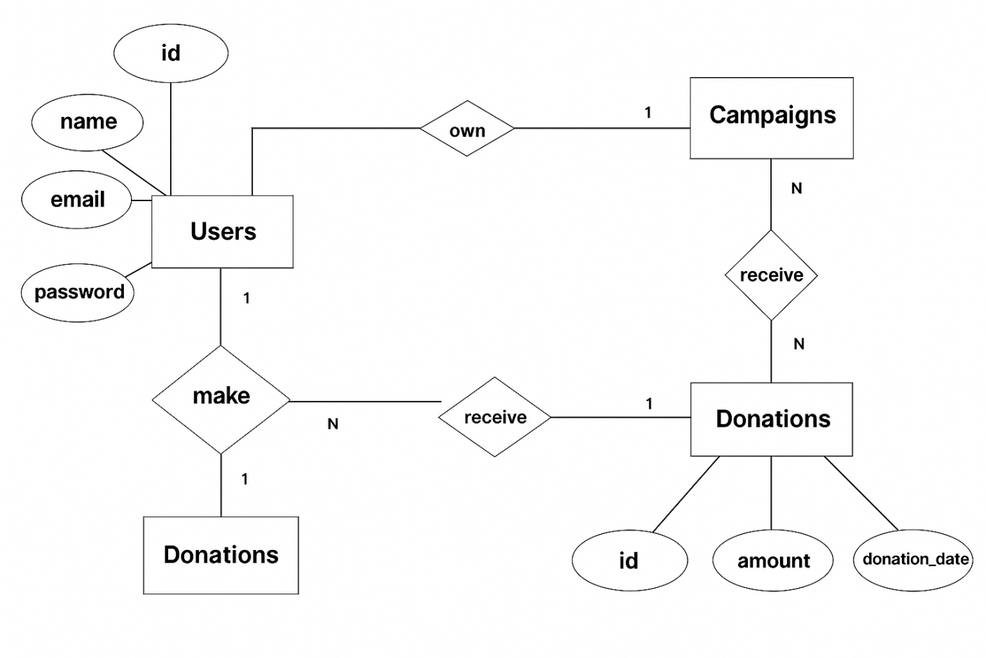Figure 3.3 ER Diagram

